ITC303 / ITC306
Assignment 2 — Requirements Baseline &
Technology Decision Pack
Subject Code | ITC303 / ITC306
Assignment | Assignment 2 — Requirements Baseline & Technology Decision Pack
Group Name / Number | CYBER SHIELD
Project Title
Team Members (Name & ID)
Date of Submission

Submission Checklist
☐ Section 1 — Requirements baseline (requirements list, NFRs, acceptance criteria, constraints)
☐ Section 2 — Models and diagrams (appropriate to your project type)
☐ Section 3 — Technology shortlist and evaluation (decision matrix included)
☐ Section 4 — Feasibility evidence / spike results
☐ Section 5 — Updated project controls (milestones, risk register, change log)
☐ Section 6 — Appendix (team contributions summary + supporting evidence)

Section 5 — Updated Project Controls
5a. Milestones / Plan Snapshot (Post-Decision, Rolling-Wave)
Milestone / Deliverable | Key Tasks | Due Date | Owner(s)
Assignment 2 Submission | Finalise all sections, internal review and submission. | 15-May-2026 | Whole team
Sprint 1: Core Setup | Flask environment setup and MySQL database schema. | 22-May-2026 | Md Rifat al Mortoza
Sprint 2: Logic Development | Code phishing scenario workflows and logic of instant feedback. | 01-Jun-2026 | Samiur Rahman
Sprint 3: UI & Admin Tools | Build the admin dashboard and complete the user interface. | 08-Jun-2026 | Abdullah Al Numan
Assignment 3 Submission | Final System testing and project delivery | 15-Jun-2026 | Whole team

5b. Risk Register (Updated)

Risk ID | Risk Description | Likelihood | Impact | Mitigation
Risk ID | Risk Description | Likelihood | Impact | Mitigation
R01 | Database Schema Errors: The complexity in the connection between users and scores can result in the loss of data. | Medium | High | Early schema validation and foreign key constraints.
R02 | Logic Inconsistency: Phishing situations might fail to elicit the appropriate feedback. | Low | High | Add a milestone in a project to explicitly test scenario logic.
R03 | Security Vulnerabilities: There may be a problem with the session management or password storage. | Low | High | Make explicit use of secure authentication and session management in Flask.
R04 | Time Limitations: Complex features might take more time than the semester deadline to be implemented. | High | Medium | Use the Moscow prioritization strictly, i.e., must requirements first.

5c. Change Log
Date | Change By | Description of Change | Reason / Impact
28-Apr-2026 | Team | Provided explicit attention to audit logging and secure authentication. | Recommended after feasibility exercise revealed security gaps.
28-Apr-2026 | Team | Added a milestone of Project Validation. | To ensure scenario logic is accurate before end implementation.
29-Apr-2026 | Team | Complete Flask + MySQL was selected as the tech stack. | Determined to be the best fit for development time and team skills.
Date | Change By | Description of Change Added | Reason / Impact
28-Apr-2026 | Team | explicit emphasis on audit logging and secure authentication. | Recommended after feasibility exercise revealed security gaps.

Section 6 — Appendix
6a. Team Contributions Summary

Student Name | Sections Contributed To | Summary of Contributions
Abdullah Al Numan | Sections 1 & 2 | Created the requirements baseline, sorted user stories, and created the UML diagrams (Activity, Use Case, Sequence, and ERD).
Samiur Rahman | Sections 3 & 4 | Carried out the technology trade-off analysis with a scoring of Flask, Django and React; carried out the feasibility spike validation.
Md Rifat al Mortoza | Sections 5 & 6 | Prepared the revised project controls, milestone plan and risk register according to the feasibility outcomes; prepared the final appendix.

6b. Supporting Evidence
Evidence Item 1 — Database ERD Validation:
• Description: This evidence confirms the relational design used to link users, scenarios, and results.
• Relevance: Validates that a relational schema is suitable for tracking progress accurately.
•

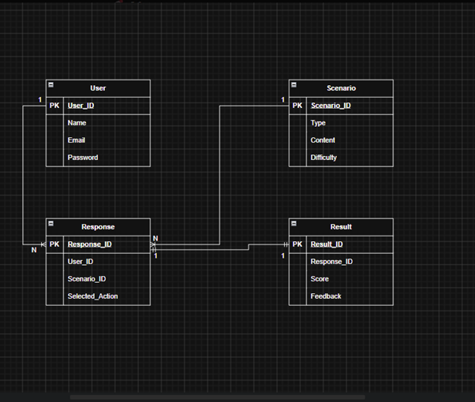 [ PREPARED BY ABDULLAH(GROUP LEADER]

Evidence Item 2 — Feasibility Proof of Concept (PoC):
• Description: A basic prototype was built to test user authentication and immediate feedback delivery.
• Relevance: Confirmed that the technical solution meets training needs and performance requirements.
• Reference: Documentation of successful login and database storage results.

[ Insert screenshot / evidence image here ]
Evidence Item 3 — Project Work Breakdown Structure (WBS):
Description: Explain that this chart defines the project roadmap, task ownership, and governance phases for the CyberShield project.
Relevance: State that it ensures accountability and tracks progress against the May 15 submission deadline.

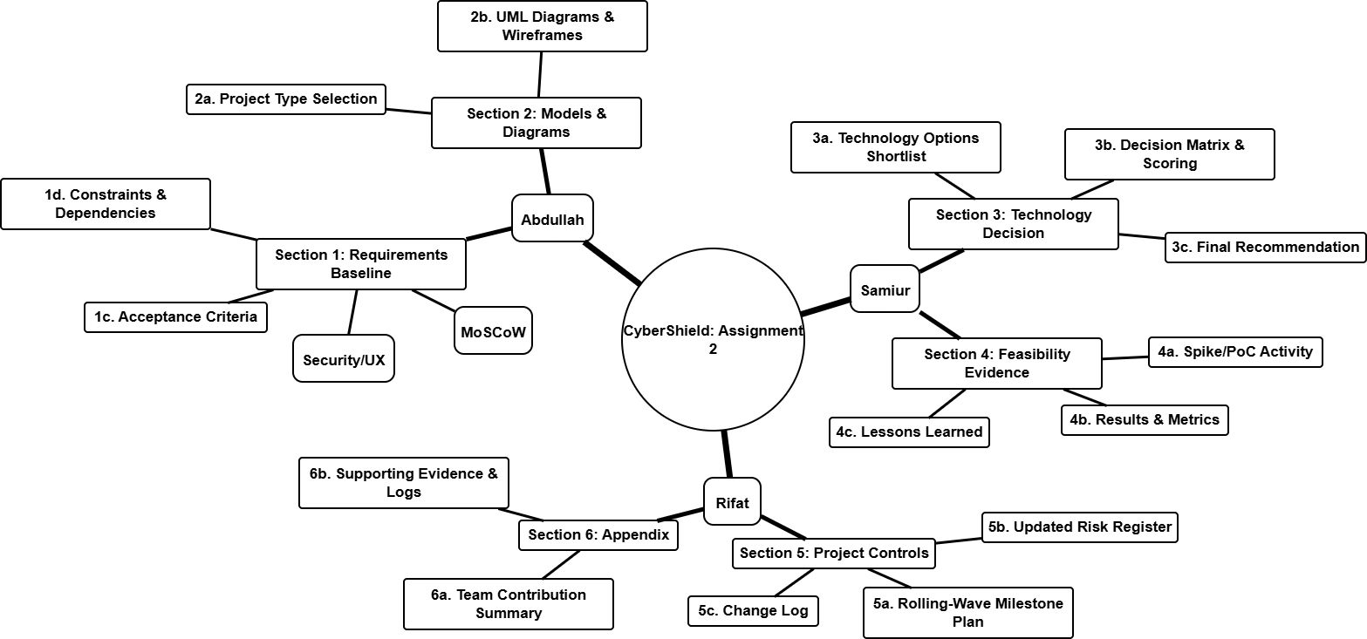
Additional Evidence / Notes:
Add any further evidence, code snippets, configuration details, or notes here. Continue as needed.

